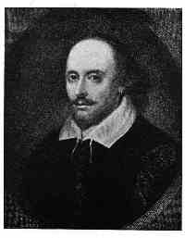
Welcome to Lit/Comp IV
2014-2015
Ms. Weingartner
Celebrating Storytelling
from
Ancient to Modern Times

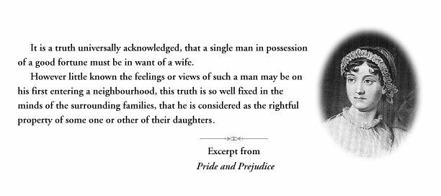
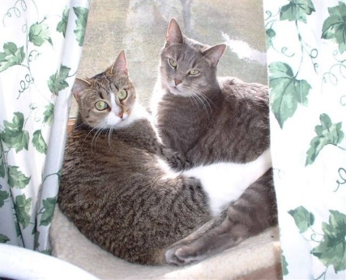

A Preview of Some Stories:

The Iliad: Helen of Troy, the Trojan War, and the Trojan horse
Beowulf: Superhero defeats monster and monster’s mom but is killed by a dragon
The Canterbury Tales: Everybody has a story to tell and a reason for telling it
Frankenstein: There’s a bit of monster in all of us
The Hound of the Baskervilles: A black glowing hound chases men to their deaths
The Metamorphosis: Gregor wakes up a BUG!
Macbeth: Double, double, toil and trouble...watch out for the witches!
The Rime of the Ancient Mariner: Who IS that spooky guy with the bird?
Bisclavet: A werewolf rips off his wife’s nose in this tale of revenge
A Tale of Two Cities: Paris, London, and the guillotine of the French Revolution
Pride and Prejudice: Opposites attract—or are they really opposites? Ah, true love!
The Romantic Poets: We love nature! Give us more nature!
Epic poetry—superheroes!— and its roots in real history
Was there a REAL King Arthur? Does it matter?
Of Angles and Saxons and Danes, oh my!
The story of Henry VIII and his six wives
How one day in September of 1066 changed England and our language forever
What Shakespeare was really all about—selling tickets and making money

A special note on Journal assignments according to Sharpsville Area School District policy: “Journal writing is a good language arts technique. I may not read your journal on a regular basis or even randomly. However, if I do read your journal and find it to contain anything that may deal with abuse, harm to yourself or harm to others, there will be no such thing as confidentiality. Your parents and/or responsible school officials will be contacted immediately.”

RESPECT
Yourself, Others, and Me

Be in your seat before the bell rings
Listen when others are speaking (including me!)
Do not deface or destroy class materials or equipment

NOT Permitted in Room 88
Chewing Gum
Food or Beverages
Cell phones
Electronic devices of any kind
Book bags

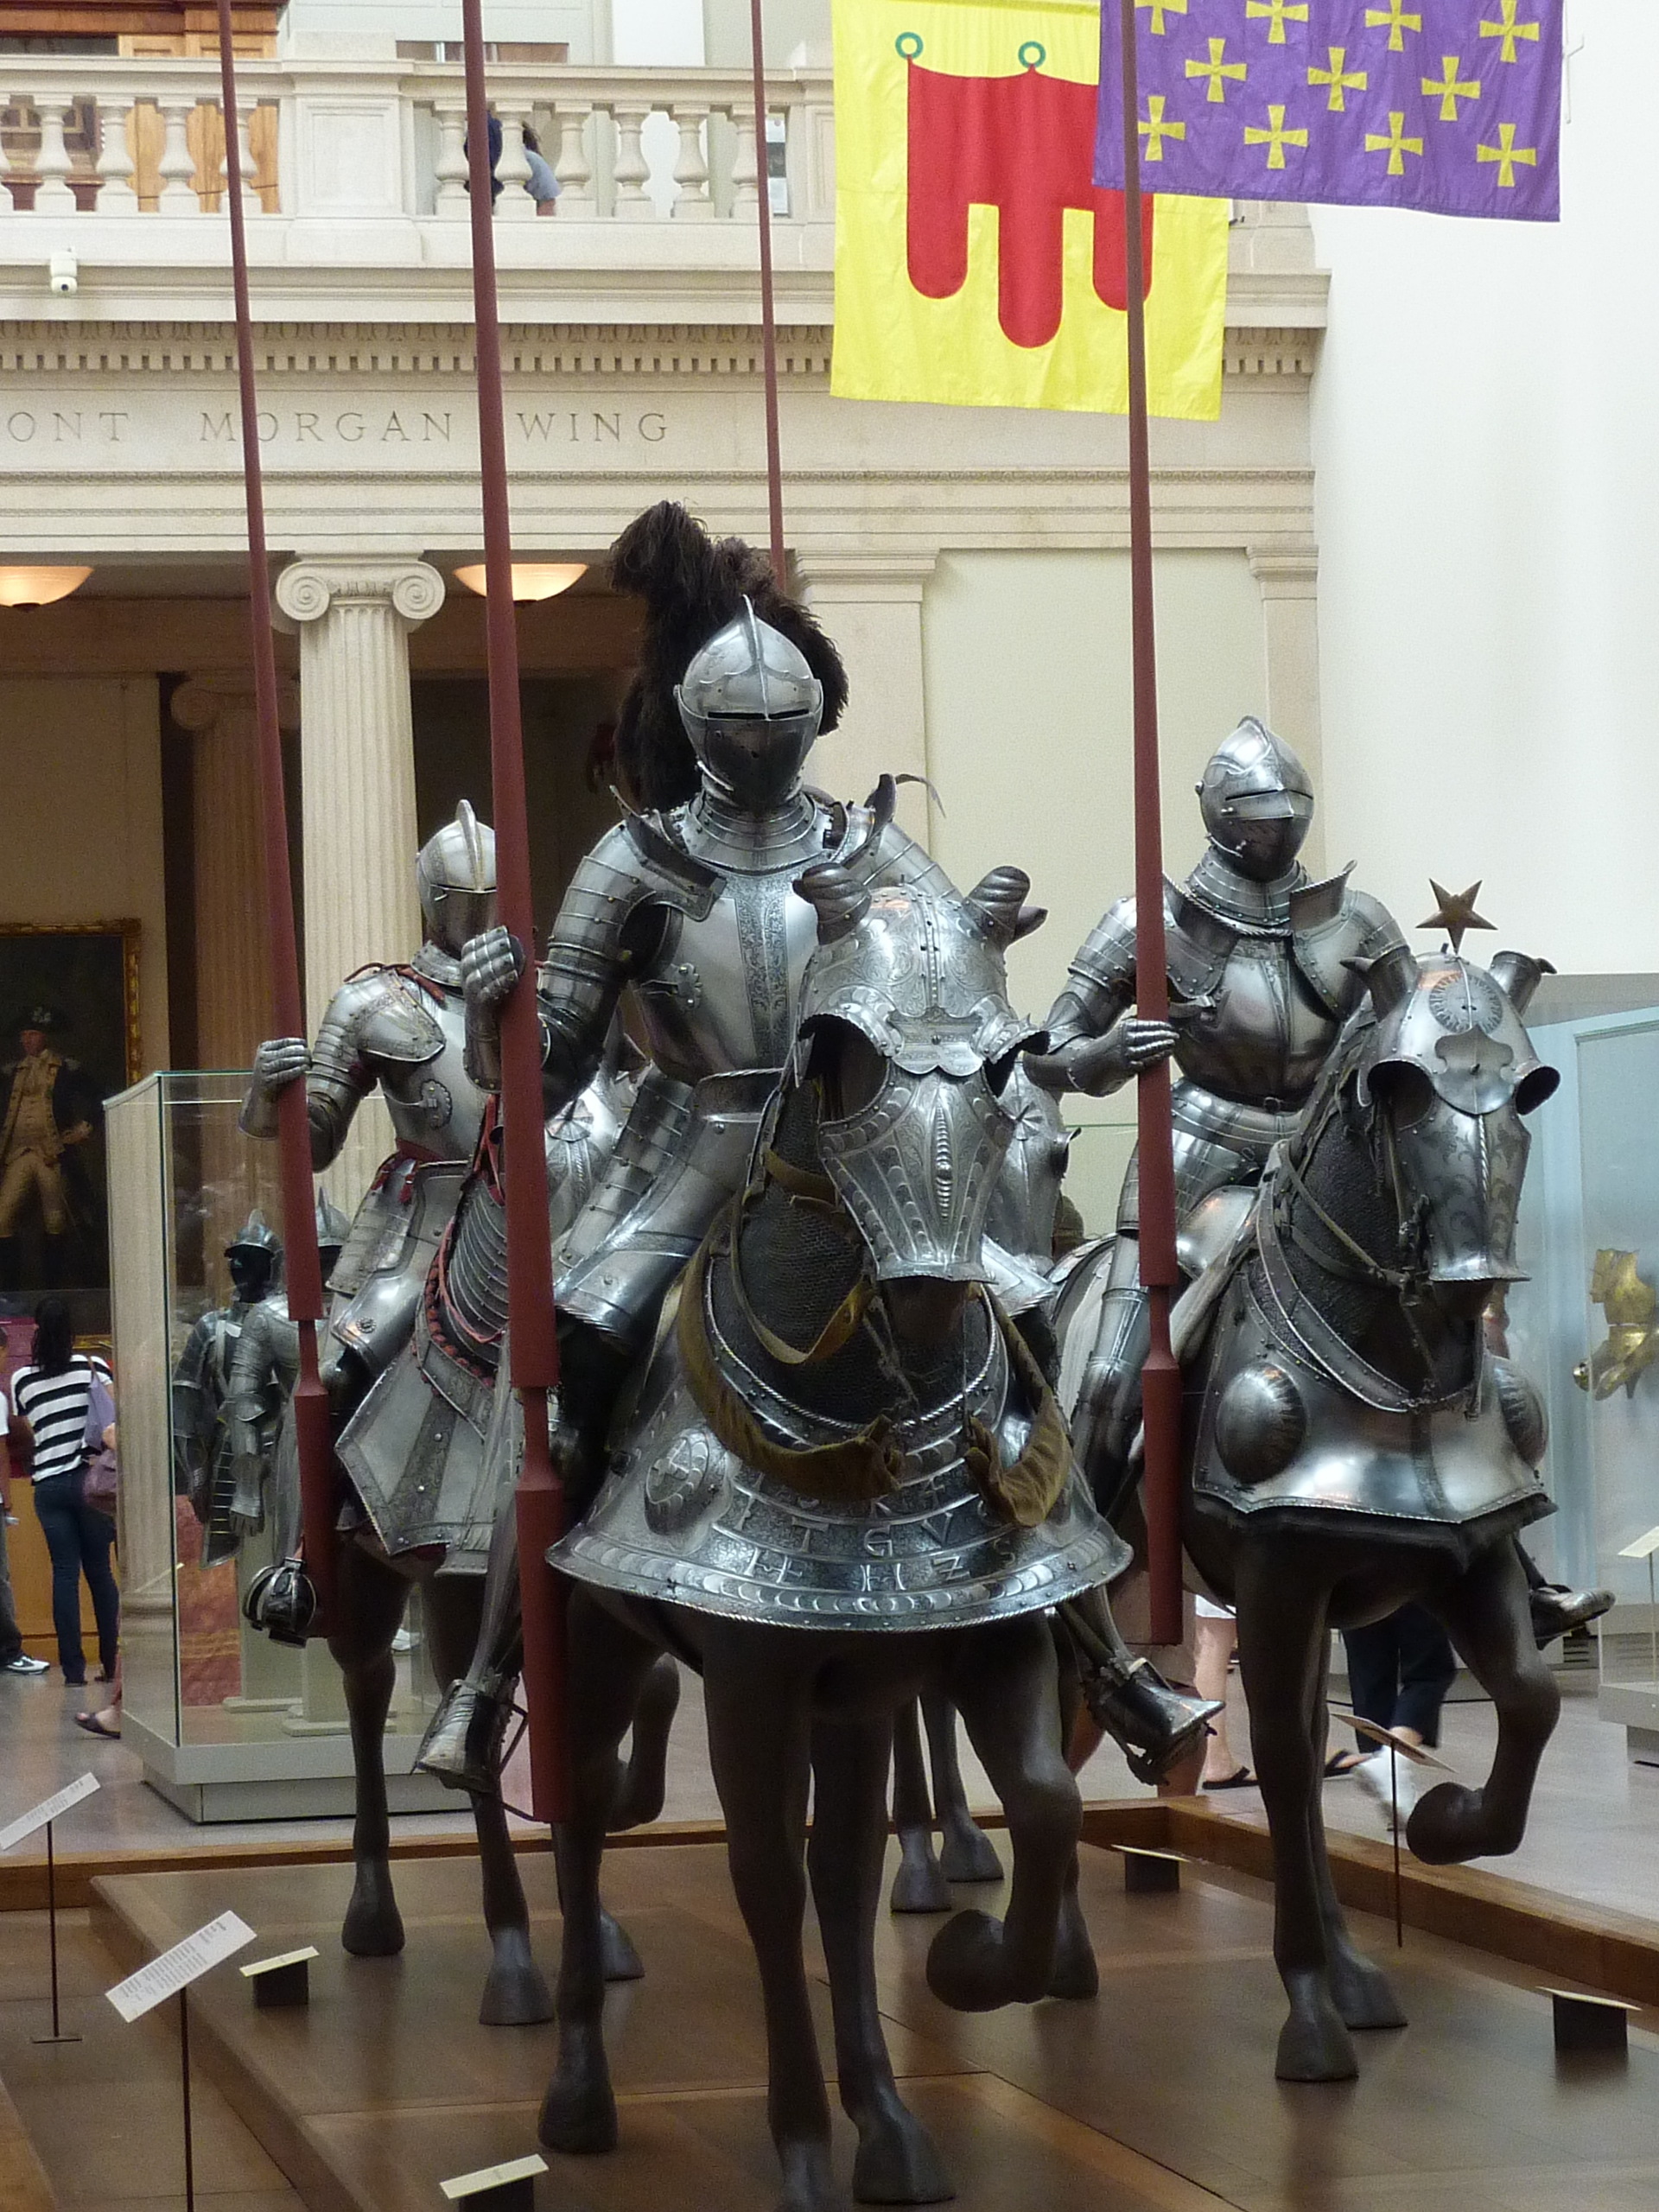

Purses: on the shelves provided in the room at all times

Book bags: in your locker (not in class)

1 student at a time may leave Room 88 with my permission

No student may leave Room 88 without signing out LEGIBLY, taking the seasonal hall pass, and signing in upon return. Failure to follow this rule will result in loss of hall privileges.

Report here BEFORE going to the nurse; go to the HS office from Room 88 before going to the nurse’s office

Literature & Composition IV
Brenda L. Weingartner Sharpsville Area High School 2014-2015 12th Grade
Phone #724-962-7861 ext 1088 email: bweingartner@sasdpride.org
ACCESS THE ONLINE BOOK @ WWW.CLASSZONE.COM; CLICK ON THE PURPLE BOOK, CREATE A USERNAME AND PASSWORD, AND USE CODE 2627913-40 FOR THE FIRST LOGIN

Lit Comp IV focuses on British and World Literature through poems, stories, novels, and plays ranging from ancient times to the present. Because most of you have never studied British history or world history, class will at times focus on the times, places, and people who created the culture from which the literature comes. For this one year alone, you will not read any American literature; think of it as an adventure into new worlds, many of which directly influenced American writing and American culture. Every effort will be made to connect assignments to students through movies, art, history, and music. We’ll also have some fun along the way.

Readings must be completed for the day on which they are due; unannounced quizzes are always a possibility, especially if the class appears unprepared for discussion of the assignment.
PLEASE NOTE: A CALENDAR OF ASSIGNMENTS FOR EACH UNIT IS PROVIDED IN CLASS AND IS POSTED ON MY WEBSITE. STUDENTS ARE EXPECTED TO MAINTAIN THEIR PROGRESS WHEN BRIEFLY ABSENT. The full textbook (with many supporting materials) is available online at www.classzone.com. ABSENCE FROM SCHOOL ON THE DAY(S) BEFORE A TEST OR QUIZ WILL NOT EXCUSE THE STUDENT FROM TAKING THE TEST OR QUIZ WITH THE REST OF THE CLASS. I may occasionally check notebooks to see that students are recording notes from assigned reading and class discussions—I’ve even been known to reward good notes with bonus points.

Periodic, scheduled vocabulary tests and open-note vocabulary quizzes will be based on class readings and discussions. Students are responsible for writing down and looking up any words they do not know in all readings. Mini lessons on grammar and punctuation will be presented as needed based on student needs.

Short writing assignments will relate to class readings, but current events are also a potential topic. We will focus on preparation for college writing classes by reviewing modes of writing (exposition, description, narration, illustration, persuasion, comparison and contrast, and literary analysis). The class will often use a workshop format in which papers are reproduced and distributed anonymously for discussion within the group. Journal writing may also be required at times; students should be prepared to share their thoughts with the class. More formal pieces of writing requiring independent research may take two possible forms: a pair of shorter research papers (3-5 pages) with presentations to the class from a topic tied to the class readings and/or British or world history OR a technology-based research project designed by the student associated with class readings or British or world history with my approval and presented to the class.

Plagiarism and cheating will not be tolerated. I consider copying homework, sharing test answers, and presenting someone else’s work as your own, original creation as dishonest and disrespectful; when detected, all parties involved will receive a zero for the assignment. Assignments and tests vary from one class section to another to minimize the temptation to cheat.
All writing assignments will be submitted to TurnItIn.com, a service designed to catch plagiarism.

Primary Texts: McDougal Littell Literature: British Literature (book cover REQUIRED!)

Highly Recommended: A notebook for class notes
A 2” spring-ring binder for class handouts, schedules, and the syllabus
A pen or pencil, every day

Tentative Novels and Plays: Marie de France. Selected romances.
Shakespeare, William. Macbeth. Chaucer, Geoffrey. Selections from Canterbury Tales.
Swift, Jonathan. Gulliver’s Travels. Shelley, Mary. Frankenstein, or the Modern Prometheus.
Austen, Jane. Pride and Prejudice. Flaubert, Gustave. Madame Bovary.
Brontë, Charlotte. Jane Eyre. Dickens, Charles. A Tale of Two Cities.
Conrad, Joseph. Heart of Darkness. Rostand, Edmund. Cyrano de Bergerac.
Well, H. G. The War of the Worlds. Kafka, Franz. The Metamorphosis and Other Stories.
Malory, Sir Thomas. Le Morte d’Artur Doyle, Sir Arthur Conan. The Hound of the Baskervilles

Grading: Every test, quiz, project, writing assignment, spot-checked homework assignment, or notebook check will earn points which will be totaled at the end of the grading period and divided by the total number of possible points to obtain a percentage grade. I make every effort to keep students informed of their current point totals and grade; however, students can keep track of their own grades simply by checking online or by recording grades as they are returned. Grades are updated at least once a week.

Following the traditional format of an A as from 90-100%, a B from 80-89%, etc., I may elect to raise a grade for positive and constructive class participation and preparation, or I may lower a grade for consistent negative or disruptive class behavior that prevents others from learning or me from teaching effectively. Knowing this, students should come prepared for class every day—with their own books, notebooks, readings, handouts, pens, pencils, and homework completed before entering class. If you become habitually late to class—in other words, not in your assigned seat when the bell rings—you will need to obtain a pass from wherever you are coming from.

While extended absences (whether from school or from my class) are often unavoidable and completely understandable, students who try to manipulate the system to avoid class will inevitably pay a price in their lack of preparation and missed connections between material from one day to another. It is always the student’s responsibility to complete assignments whenever absent, for whatever reason. Missed extra credit opportunities or unannounced quizzes from days missed cannot be “made up.”

Late assignments lose one letter grade from what they would otherwise have earned for each day late. Make-up work must be completed within one week of return to school, before or after school. It is the student’s responsibility to schedule any missed tests or other projects immediately upon return to school. SEE the Student Planner for School Policy on this issue.

Extra help is cheerfully offered and available upon request. If you’re having trouble with anything, come talk to me. I’ll do my best to help. I love what I teach, and I love teaching!

Tentative Reading Units
Literature & Composition IV: 2014-2015
(Novels may be substituted in appropriate units)

Unit One: The Heroic Tradition: Epic Poetry
Lecture and handout: Epic poetry introduction and definition
Homer selections from The Iliad
background on the Trojan War: myth versus reality versus literary sources
Movie/visual insights: view selections from Troy and/or Alexander
Transition to English history, Stonehenge to 1066 AD: Lecture, videos, handouts
Anonymous selections from Beowulf
Lecture and discussion of Old English examples: the German roots of English

Unit Two: The Romance Tradition: the Norman Conquest’s impact on England
tribal culture versus feudal culture
the conquered versus the conquerors
Anglo-Saxon versus French language
epic literature versus romance literature
the need for Robin Hood & King Arthur
Marie de France handout: Bisclavret or another lai
Margery Kempe selection from The Book of Margery Kempe
Various selections from The Paston Letters
Anonymous Robin Hood (a ballad and a story)
Introduction to Romance (in contrast to Epic): lecture, handouts
The Gawain Poet selections from Sir Gawain and the Green Knight
Sir ThomasMalory selection from Le Morte d’Artur: King Arthur, Guenevere & his knights
Selected movie scenes: First Knight; Braveheart

Unit Three: The Renaissance Tradition: conflicts that (should) matter to Americans
the Wars of the Roses and the Hundred Years’ War
the Protestant Reformation and Martin Luther
all of Henry VIII and his six wives
Queen Elizabeth I’s struggle against Mary, Queen of Scots
the Renaissance in England (Shakespeare)
Sonnets: Italian, Speserian, and Shakespearean
Selected scenes from Shakespeare in Love, Elizabeth, and documentaries
William Shakespeare Macbeth
Movie Roman Polanski Macbeth
Lecture: the English Civil War, Oliver Cromwell, and the Puritans

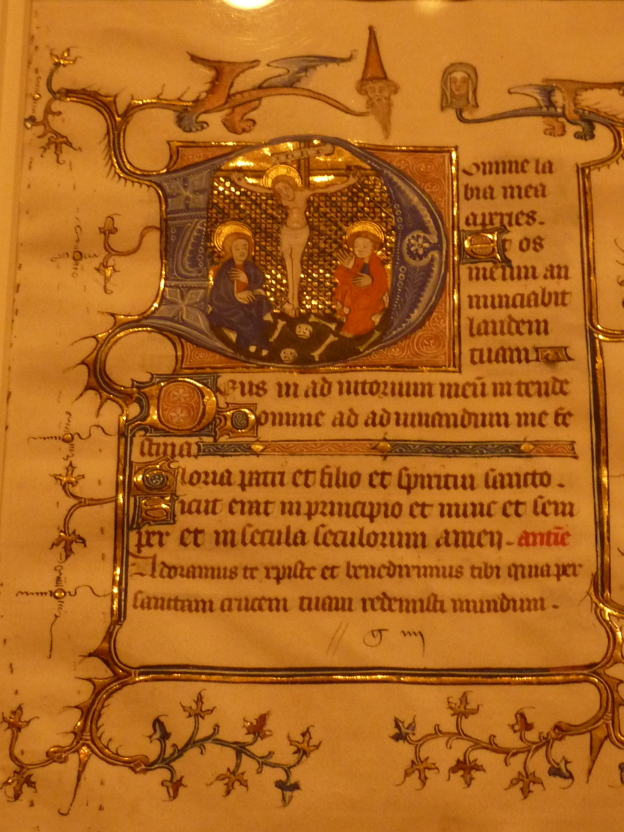

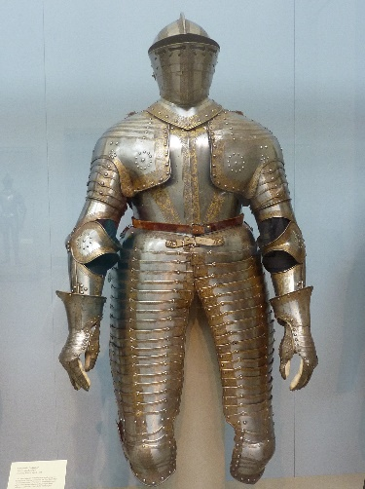

Unit Four: The Restoration, the Enlightenment, and the Age of Satire
Daniel Defoe selections from Robinson Crusoe
Alexander Pope selections from The Rape of the Lock
Jonathan Swift selections from Parts 1 and 2 of Gulliver’s Travels
Jonathan Swift “A Modest Proposal”
Voltaire selection from Candide
Fanny Burney selection from her journal
Mary Wollstonecraft “A Vindication of the Rights of Women”

Unit Five: The Rise of Romanticism and its impact
Lecture: Rise of Romanticism, Characteristics of Romanticism, and connection to Transcendentalism
Selected poems from textbook and handouts
Johann Wolfgang von Goethe selections from Faust, Part One (handout)
Samuel Taylor Coleridge The Rime of the Ancient Mariner and “Kubla Khan”
Mary Wollstonecraft Godwin Shelley Frankenstein
Jane Austen Pride and Prejudice

Unit Six: The Rise of Realism, Victorianism, and Naturalism
Lecture on characteristics of realism and historical impact of Queen Victoria’s reign
Charles Dickens David Copperfield OR A Tale of Two Cities
Alfred, Lord Tennyson “The Lady of Shalott,” “Ulysses,” “Crossing the Bar”
Robert Browning “My Last Duchess” and “Porphyria’s Lover”
Anthony Trollope “Malachi’s Cove”
Elizabeth Cleghorn Gaskell “Christmas Storms and Sunshine”
George Eliot selection from Middlemarch AND Silas Marner
Thomas Carlyle “The Condition of England”
Matthew Arnold “Dover Beach”
A. E. Housman “To an Athlete Dying Young”
Oscar Wilde The Importance of Being Earnest

Unit Seven: Symbolism, Expressionism, and early modernism
Handout: a selection of Symbolist poetry
Handout: plays by Ibsen, Chekhov, Strindberg, Shaw, Synge, and others
Handout and textbook: Poetry of World War I
Remarque All Quiet on the Western Front
Kafka The Metamorphosis

special note on Journal assignments according to Sharpsville Area School District policy: “Journal writing is a good language arts technique. I may not read your journal on a regular basis or even randomly. However, if I do read your journal and find it to contain anything that may deal with abuse, harm to yourself or harm to others, there will be no such thing as confidentiality. Your parents and/or responsible school officials will be contacted immediately.”
A special note on Journal assignments according to Sharpsville Area School District policy: “Journal writing is a good language arts technique. I may not read your journal on a regular basis or even randomly. However, if I do read your journal and find it to contain anything that may deal with abuse, harm to yourself or harm to others, there will be no such thing as confidentiality. Your parents and/or responsible school officials will be contacted immediately.”
A special note on Journal assignments according to Sharpsville Area School District policy: “Journal writing is a good language arts technique. I may not read your journal on a regular basis or even randomly. However, if I do read your journal and find it to contain anything that may deal with abuse, harm to yourself or harm to others, there will be no such thing as confidentiality. Your parents and/or responsible school officials will be contacted immediately.”

